Chapter 16, Problem 15.

For the circuit in Fig. 16.38, calculate the value of R needed to have a critically damped response.

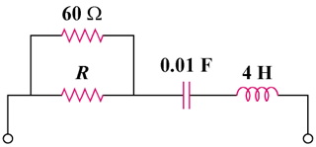

Figure 16.38
For Prob. 16.15.

